choosing a path in freedom

Stories of Enslaved people at Hampton

### student activity book

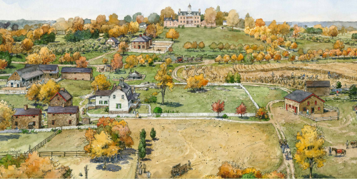

# LEWIS & NANCY DAVIS

Nancy Davis was born in April 1833 on Cowpens Plantation (the farm immediately east of Hampton). According to relative James Howard's *Memoirs of the Ridgelys of Hamp*ton (1894), her father was Ambrose Brown (c. 1805-lv. 1860), "our old marketman at Cowpens." Nancy's principal role in first the Howard, then Ridgely households was childcare. She looked after three generations of children over her long life. Sometime during the 1850s, Nancy had married Lewis Davis.

Lewis/Louis Davis (1833-1906) was born at Oakland, Frederick County, coming to Hampton at age eight. He would have known Nancy well from the time she started working at Hampton during the early 1850s, though they certainly could have met before, as Nancy lived less than a mile away at Cowpens. They married before 1860, by which time Lewis is listed as a house servant in the clothing lists. He was receiving livery coats, a sign of a very public and high- status position such as coachman.

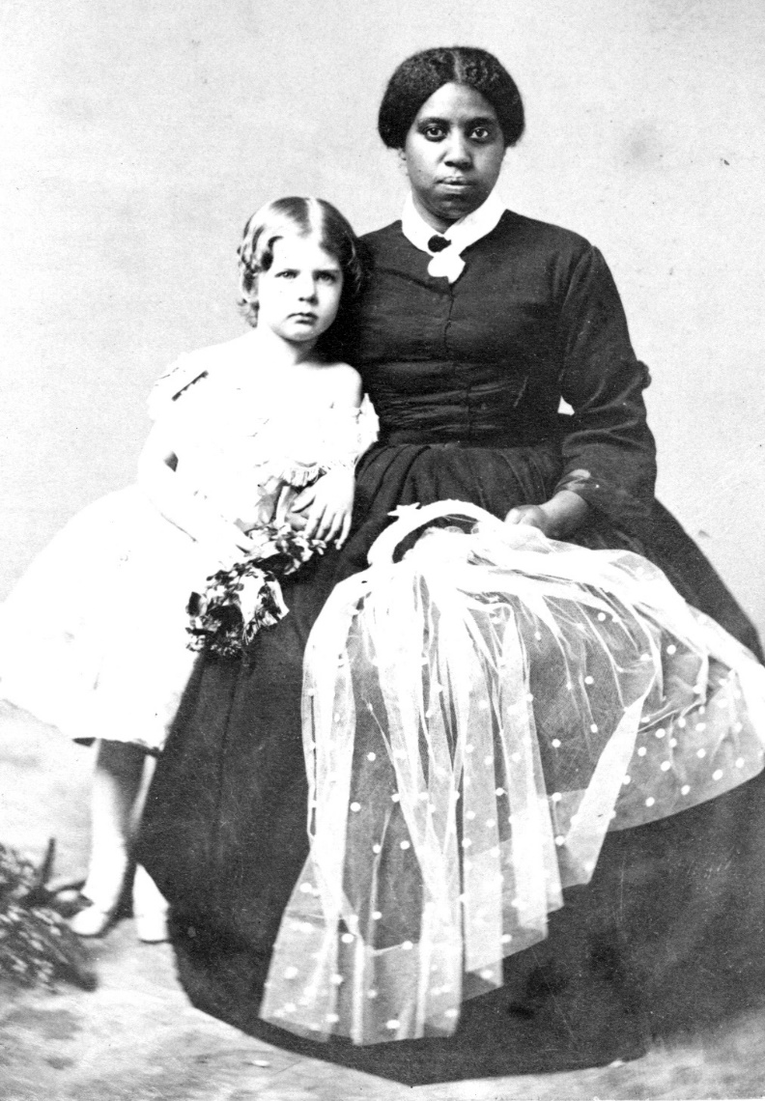

# NATHAN & Ellen HARRIS

Ellen Davis Harris (1831-1911) was an older sister of Lewis Davis, 10 years old when she arrived with her parents and siblings at Hampton. Within a few years, at about age 17, she married Nathan Harris (c. 1815-lv. 1880), the senior coachman at Hampton who was, according to Ridgely relative James Howard, "...the driver who used to handle the four in hand so skillfully as to command the admiration of the people of Baltimore was among those missing when I came home after the war was over." The marriage of Ellen and Nathan was later confirmed by Ellen's sister-in-law Nancy Davis, in a note written on the page from the early 1850s in the Clothing Account Book which recorded "Ellen's children." In c. 1894, Eliza Ridgely III annotated the page, "Nathan's wife, so says Nancy Davis."

Ellen was not a house servant, but her work at Hampton required aprons. Since she is often listed in the records alongside her sister Caroline Davis the dairymaid, perhaps working in the dairy was her principal labor on the farm. Other labor requiring aprons would be the preparation of the dozens of hams produced on the farms each year. Her other efforts would have been directed to the care of the nine children that were born to Ellen and Nathan. Their daughter named Isabella ("Belle") Harris born in 1862, was one of the last children to be born enslaved at Hampton.

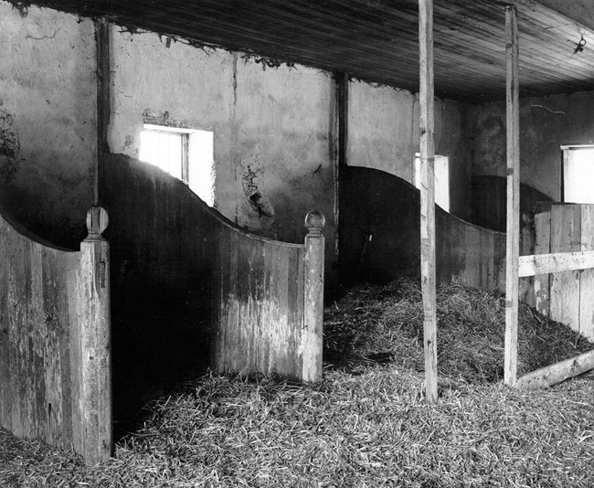

# aNNIE “BONES” DAVIS WILLIAMS

Anne Davis Williams lived from 1835 to about 1890. Anne was an enslaved house servant and a family favorite because of her nursing skills. James McHenry Howard (a medical doctor by profession) went to great lengths in his *Memoirs of the Ridgelys of Hampton* (1894) to note Anne's character and talents.

“Anne was one of the best nurses I have ever seen, and to the instincts of a lady she joined the qualities of a quiet manner and soft footfall and seemed to know exactly what to do and how to do it whenever any change was necessary in the sick chamber – She was also an excellent cook and good housekeeper and had the art of preparing nice little things in such a way that even a sick person was tempted against his will to eat...”

Helen West Stewart Ridgely, wife of Capt. John, also noted her nursing skill. "Anne Davis known to us all as 'Anne Bones' because of her particular skill in bandaging and nursing..."

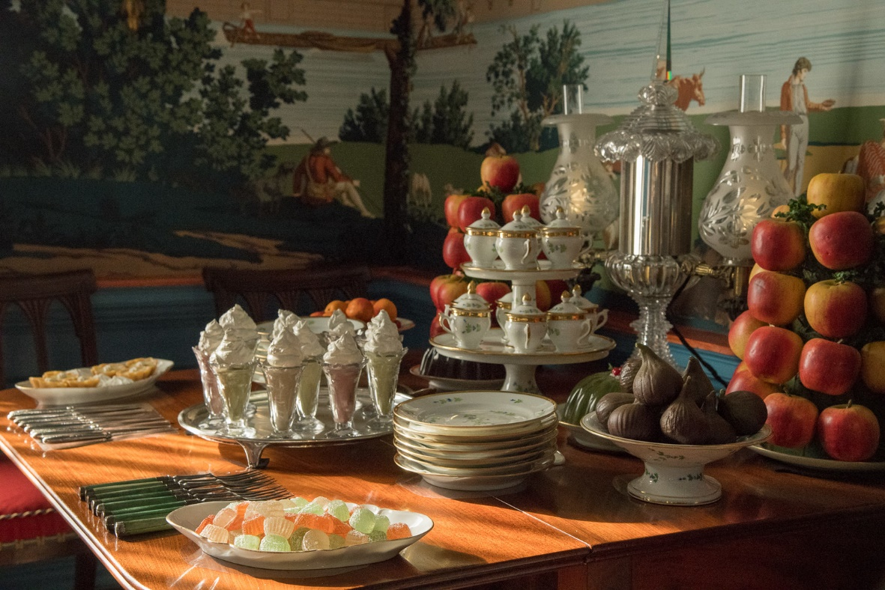

# HARRIET HAWKINS

Another key member of the household was Harriet Hawkins (1807-lv.1886), who appears to have been head dressmaker. Harriet received finer articles of clothing, accessories such as bonnets, and Ridgely family hand-me-downs. Harriet's importance to the story of enslavement at Hampton, however, goes deeper than her just her domestic role.

Harriett Hawkins was at Hampton throughout John and Eliza Ridgely's ownership. It is likely that she was owned by John himself. Born about 1807, Harriet was just 17 years old she became the mother of John Ridgely’s son, Charles Hale Brown. This was in 1824, between the time of the death of John's first wife Prudence Gough Carroll Ridgely in 1822 and his second marriage to Eliza Eichelberger Ridgely in 1828. According to her family history, Brown was sent to Boston between the ages of 14 and 17 for an education. Documents in the *Chattle Records of Baltimore County* record that Brown was manumitted from slavery by his father John Ridgely on August 28, 1846 at the age of 22 years old. One possible reason for the timing was the coming departure of John and Eliza Ridgely on an extended trip abroad. Whatever the case, Charles Hale Brown was the only one of the numerous enslaved individuals John owned to have been freed before general Emancipation.

As a house servant who assisted with making, mending, and altering clothing, Harriet Hawkins would have been regularly in contact with Eliza Ridgely. The records are silent on whether Eliza knew about Harriet's son. Nevertheless, they do confirm certain aspects of what appears to be special treatment.

In the 1840s and early 1850s, Harriet Hawkins had several additional children: Sarah (b. 1841), Nelson (b. 1843), Mary (b. 1845) and Louisa (b. 1854, when Harriet was in her late 40s). All the children but Mary were clearly house servants, and Nelson's clothing indicates he served as both an apprentice waiter and cook. All these children are recorded using the surname Hawkins. The identity of the father of these children is still unknown. However, a free Black laborer named Nelson worked at Hampton for two years in 1842 and 1843. It seems possible, given the common pattern of family names, that Harriet’s son Nelson (b. 1843) might have been named for his father. Unfortunately, no more is known about Nelson, as he is recorded in John Ridgely’s Memorandum Book, which did not note a surname.

# NICK & DINAH TOOGOOD

Dinah Toogood (c. 1795-c. 1882). The kitchen was a center for activity in the house. Dinah, wife of Nick Toogood, was the head cook in the 1840s-1860s. She oversaw the kitchen, and Eliza Ridgely III noted that she was a good "fine cook." Ridgely records show Dinah receiving several coarse aprons a year, indicating the possibly messy nature of her work. Dinah had first come to Hampton in 1830, when she was purchased by John Ridgely from Hugh Birckhead for $250. Her husband Nicholas (Nick) Toogood (1786-1879) did not come to Hampton until several years later in the late 1830s. The Toogoods had four children, two of them (James and Marie) died as babies. A third child, Agnes, was born in 1845, died in 1847. Daniel (b. 1843) the fourth child, may well have died before 1850. After the death of Sam Brown around 1861, Nick was probably the oldest enslaved worker on the estate.

It was noted that Nick "was a sort of spiritual leader among the [enslaved at Hampton] & if anything in the way of religious ceremonial or worship was going on, Nick was sure to have a prominent place recounts this episode." Howard also recounted an episode showing an example of resistance to slavery:

One of the well-known characters among the slaves was an old man by the name of Nick Toogood – he used to work around the grounds about the house as a general utility man and was usually complaining of Rheumatism and misery in the back – but this was thought to be a plea on his part for relaxation of work.

However, he put the plea in, one Sunday morning when he was told to do something or other and was excused as an invalid. Apparently when the family saw him in the morning, he seemed all bent together and could hardly drag one foot after the other – but as the ladies were seated in Epsom Chapel, an hour or so afterwards – Miss Henrietta happening to look out of the window her attention was attracted by seeing an old negro man climbing lightly over an adjacent fence and walking with long strides towards the village of Towsontown – It was old Nick.

# MARK POSEY

Mark Posey was a key member of the Hampton household. As noted in an account book, he was "A waiter at Hampton, and a good one." In addition to serving a table, a head waiter was responsible for the care of the fine porcelain, glass, and silver on display in the Dining Room, keeping the lighting fixtures in good order, admitting guests to the house, and numerous other duties. A head waiter was often in the public eye, and was expected to dress well. In 1835, for example, Mark received many items related to his position (livery "roundabout" (cape), white aprons, gloves, etc., plus fine clothing such "a yellow cloth waistcoat [vest] of Mr. R.'s, very good one" or a “gold laced” livery coat.

As a young man in the late 1830s--1840s, Mark had been the father of several children by Rachel, a house servant. Mark and Rachel's first child was Rebecca, born in 1837, and followed by two more daughters in the early 1840s (Mary, Alice). Alice Posey was recorded by Didy Ridgely on the Christmas Gifts list as being her "first protégé" in 1845, but she died while Didy was away in Europe for two years in 1846-1848.

Alice Posey's older sister Rebecca Posey had a very different experience than her sister the protégé. In the 1840s, as a small child, she worked in the kitchen under the supervision of Dinah Toogood. At age 15 Rebecca left Hampton seeking her freedom. It is unclear why Rebecca Posey sought her freedom alone. It was very rare for women to flee alone as Rebecca did on August 20, 1852. Historically, women left solo when they were about to be sold, to avoid punishment, or to remove themselves from constant abuse. The newspaper advertisement records a physical description of the 15 year old:

RAN AWAY from the farm of John Ridgely, Esq. in Baltimore County...a light colored NEGRO GIRL who calls herself REBECCA POSEY, about five feet one or two inches high, and fifteen years old, with a round good looking face. She had on when she left a dark blue striped dress, a dark blue shawl, and no bonnet.

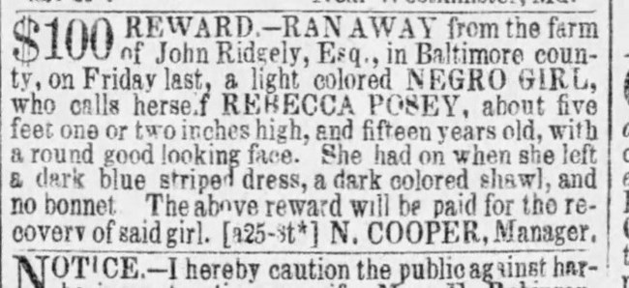As far as can be determined from the records, Rebecca Posey made good her escape and never returned to Hampton. Two notices in the *Baltimore Sun* note that she was living in Baltimore in 1863-1864, but no other records have been found. Rachel, Rebecca's mother, lived until late 1860 or early 1861.

Mark Posey took a younger wife (Eloise/Heloise/Louisa Humphries) with whom he had a child (son Edward) later in 1861. Mark and his new wife and child fled with several of her relatives in 1863, but were quickly captured and returned to Hampton.

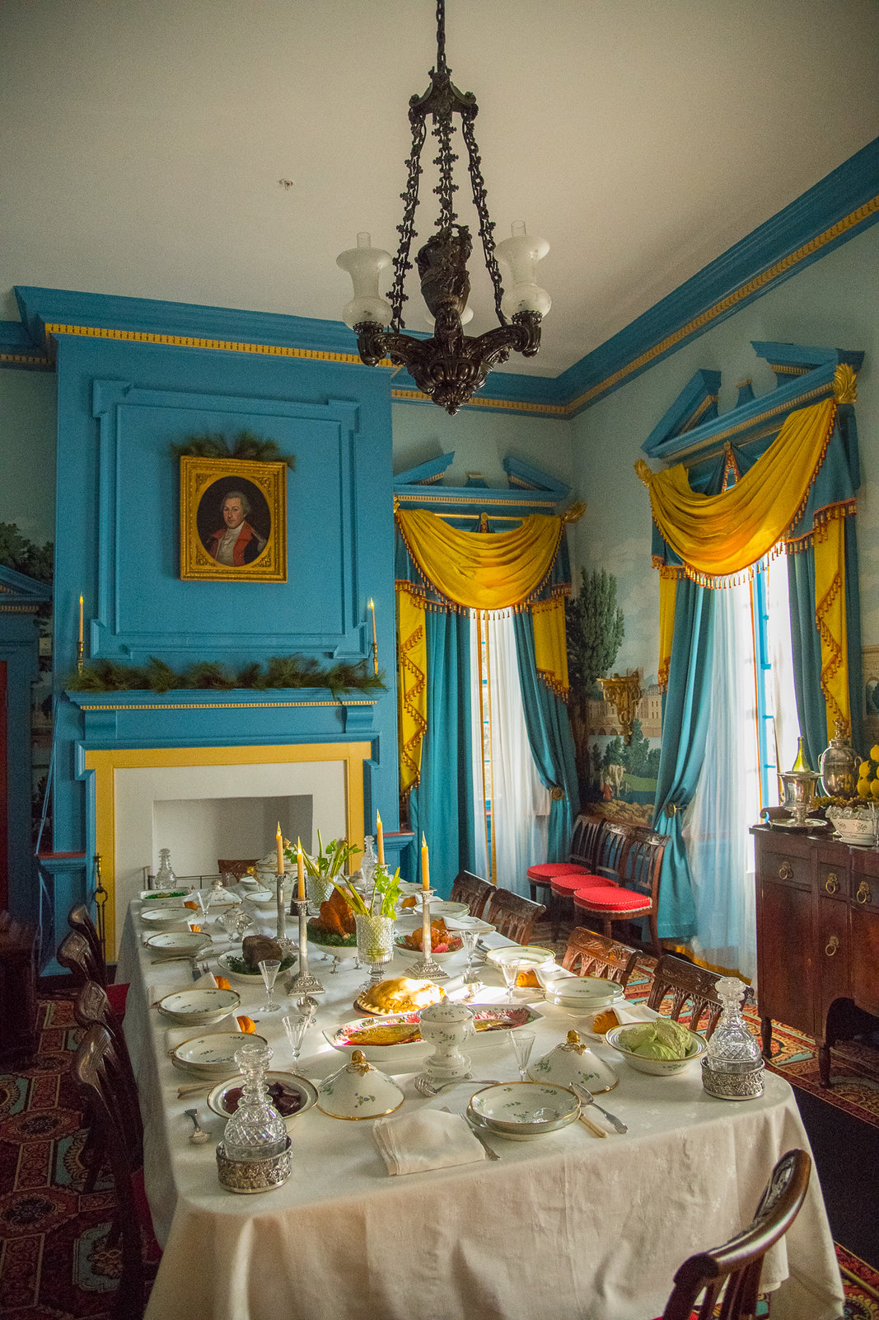

# JIM PRATT

Jim Pratt was born in the year 1834 and was the youngest of four siblings (John, Joe, Caroline, and Jim) born to Charlotte, a house servant. Their father was likely Henry Pratt, an enslaved farm worker purchased in 1831 who continues to appear in Hampton records up until c. 1863. Jim Pratt was one of the large group who fled slavery in 1863 that included Mark Posey, Louisa Humphreys Posey, Mary Humphreys, John Humphreys, George Humphreys, and Jim Gully. Most of this group of freedom seekers had been purchased together by the Ridgely’s in 1841, but Jim Pratt was the outlier having been born on the plantation. Details of the recapture of this group is unknown but records indicate that the groups was held in a Baltimore City jail and the Ridgelys had to make a payment to retrieve them and bring the group back to the plantation.

In May 1864, Jim Pratt is again listed at Hampton in a clothing list. It is believed that Jim Pratt married his wife Laura in the year 1856 and they had three children: James, George, and Lizzie. Jim worked as a farm laborer. He was described by James McHenry Howard as “When a younger man he took pride in eclipsing any hired hand in the harvest field, and in forking hay he generally succeeded in breaking down any rival.”

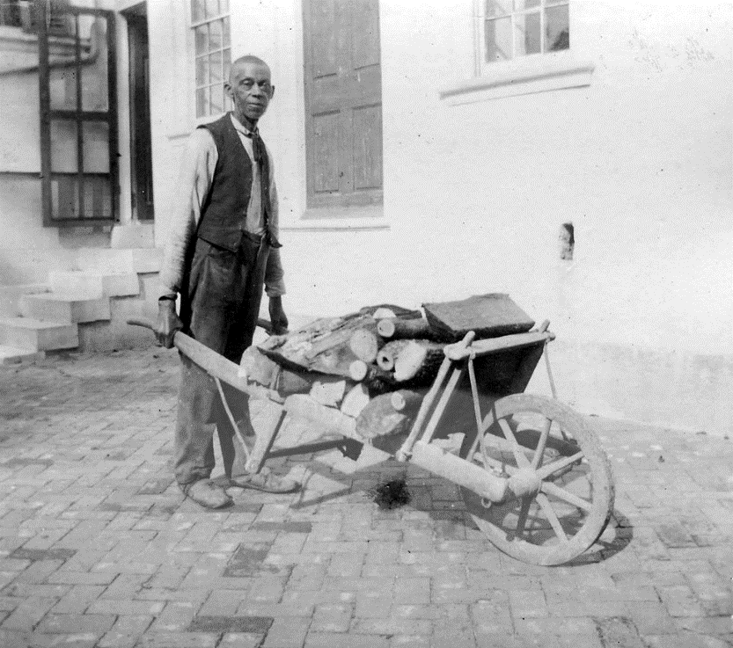

choosing a path in freedom

### student worksheet

# what is hampton national historic site?

Hampton National Historic Site is a unit of the National Park Service that preserves the core of what was once a vast commercial, industrial, and agricultural estate that encompassed nearly 25,000 acres at its height. Hampton is the collection of stories of the many people who came through the estate - the few who chose to be there, such as the Ridgelys (owners of the estate), the several who were there out of necessity (indentured servants and paid laborers), and the many enslaved people forced to be there. All played a vital role in the development of the estate and their stories help us to explore history from many different perspectives.

With the outbreak of the Civil War in 1861, enslaved workers at Hampton faced difficult choices. Some considered seeking freedom on their own while others chose not to take such a great risk. Even after emancipation in 1864, formerly enslaved people faced an uncertain future and needed to make difficult choices to determine what freedom would mean for their individual lives. Would it be better as a free man or woman, to leave Hampton and begin anew, or to stay at Hampton as paid workers?

# activity

## Choose your team

Select one group member for each of the following roles:

* Scribe—This person will take notes for the group and write up the group replies
* Speaker—This person will speak on behalf of the group during the class presentations
* Researcher—This person will find and collect appropriate resources
* Facilitator—This person will keep the group on task and make sure discussion runs smoothly and assignment is complete on time
* Challenger—This person will raise questions during the discussion and offer alternatives to further the discussion

## explore the story

* In your group, review the individual or family biography
* Discuss with the group what options are available to the person(s) described and decide what choice you would make in their situation. Be sure to consider:
  + Resources available to the person
  + Limitations
  + Other things that might influence their decision

## choose your path

Document your group’s choices on the worksheet and prepare to present to the class.

# our group

|  |  |
| --- | --- |
| FACILITATOR |  |
| RESEARCHER |  |
| CHALLENGER |  |
| SCRIBE |  |
| SPEAKER |  |

# OUR STORY

**Who is your story about? Include details to help the class understand who they were.**

|  |
| --- |
|  |

**What choice would you make after emancipation in 1864?**

|  |
| --- |
|  |

**What are your reasons for this choice?**

|  |
| --- |
|  |